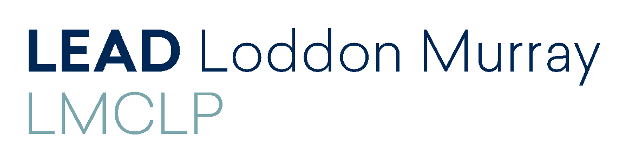
2019 Loddon Murray Community Leadership Program
A great professional development opportunity for your staff
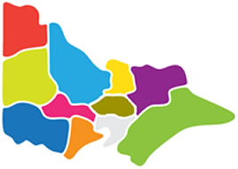
Would you like your staff to:
- Build their skills and confidence?
- Hear about regional issues & innovative ideas for action?
- Meet leaders from all walks of life?
- Expand their networks?
- Learn more about them self & increase their effectiveness?
- See how they can make a difference in YOUR workplace & the wider community?
Applications are now open for the 2019 Loddon Murray Community Leadership Program which will being in February next year.
Open to all residents of central and northern Victoria, the program includes 22 days across the region and beyond (including study tours to Melbourne and Canberra) and will explore themes such as:

- Vision of the region
- Leadership skills
- Personal development and growth
- Art and culture
- Regional economies and tourism
- Health and wellbeing
- Education and youth
- Agriculture, water and environment
- Justice and social enterprise
- The political landscape
- Innovative communities

Underpinning every program day will be leadership development with participants encouraged to build their skills, knowledge, confidence and networks so they can make a positive difference in their community – and of course YOUR workplace.
So if you have a staff member that has the potential to grow your business/organisation, consider supporting them to undertake the LMCLP in 2019.
To find out more about the Loddon Murray Community Leadership Program visit
www.leadlm.org.au
Applications close on 30 September 2018

Buloke Shire Council • Campaspe Shire Council • Central Goldfields Shire Council • City of Greater Bendigo
Gannawarra Shire Council • Loddon Shire Council • Macedon Ranges Shire Council
Northern Grampians Shire (part) • Mount Alexander Shire Council • Swan Hill Rural City Council

